**PROJECT ON MySQL**

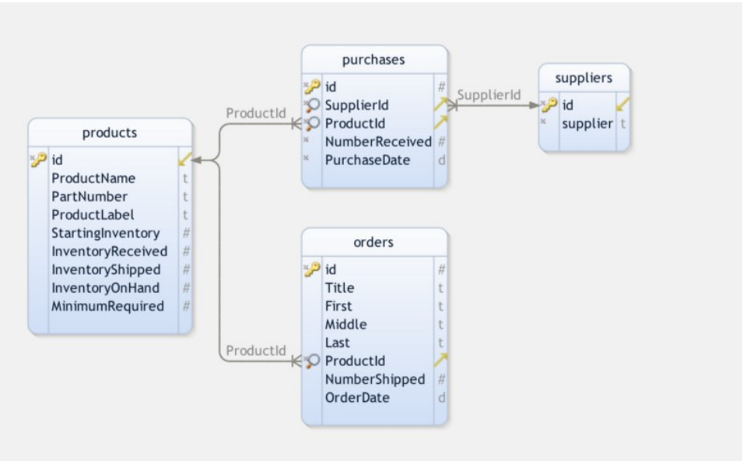

The aim of this project is to create an inventory system, refer to the diagram above to create your db.

The diagram shows the number of tables along with the relationship between tables. All the tables with respective columns are provided.

You are required to create the system with proper tables along with their relationship. You are also required to put in around dummy data inside the table so as to get some insights.

**INVENTORY_SYSTEM**

**1)command to create a database for storing all above tables.**

create database inventory_sys;

show databases;

use inventory_sys;

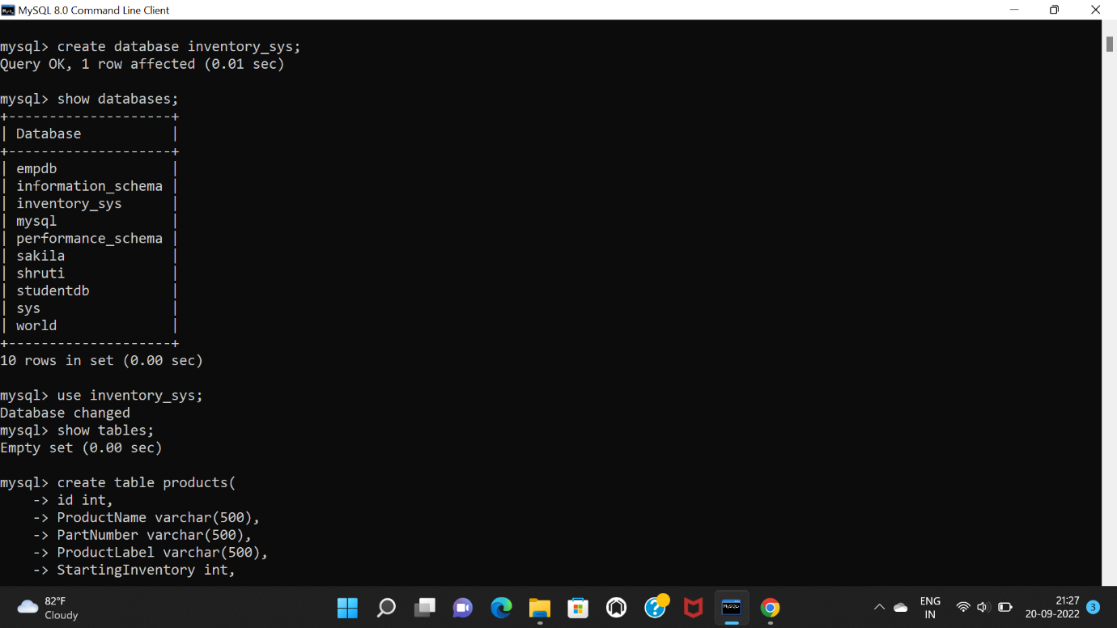

**PRODUCTS TABLE**

**1)command to create products table.**

create table products(

-> id int,

-> ProductName varchar(500),

-> PartNumber varchar(500),

-> ProductLabel varchar(500),

-> StartingInventory int,

-> InventoryReceived int,

-> InventoryShipped int,

-> InventoryOnHand int,

-> MinimumRequired int,

-> primary key(id)

-> );

**2) command to describe products table.**

desc products;

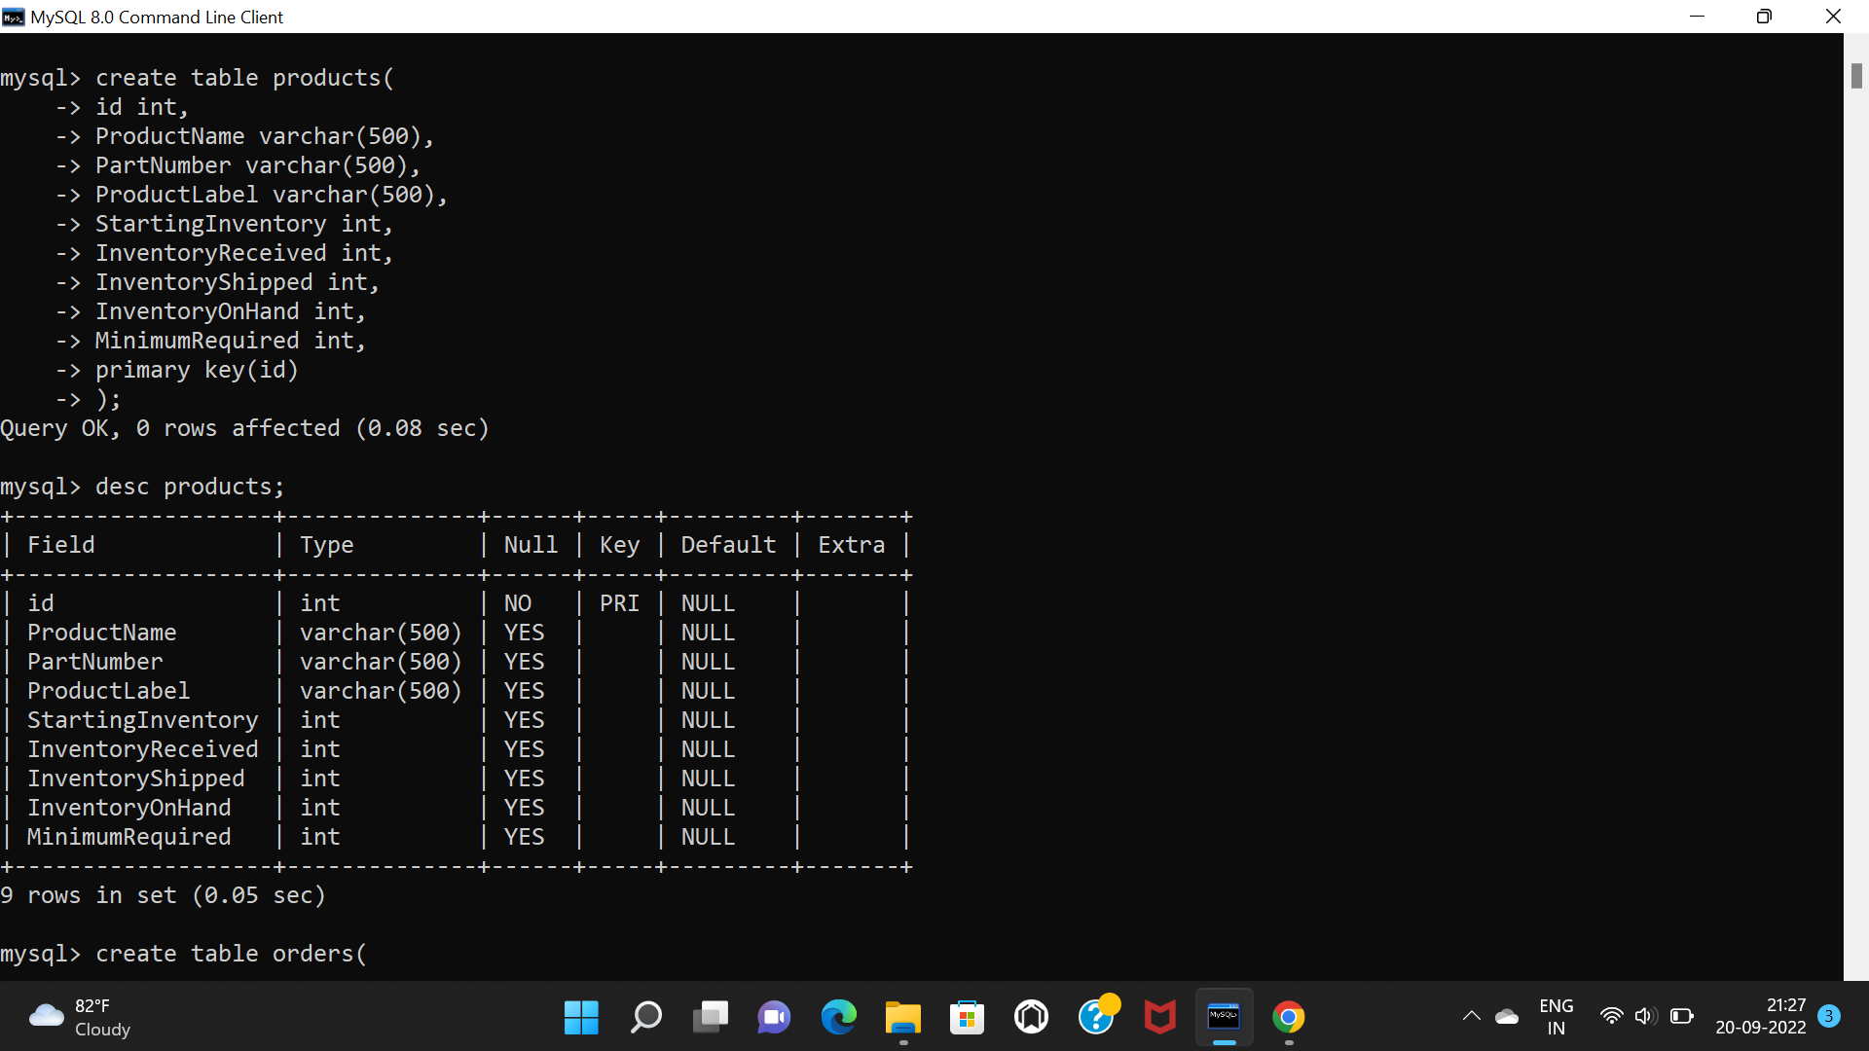

**3)command to insert records in products table.**

insert into products(id,ProductName,PartNumber,ProductLabel,StartingInventory,InventoryReceived,InventoryShipped,InventoryOnHand,MinimumRequired)

-> values(1,"Dell XPS","XPS 13","Dell XPS 13",5500,360,75,5785,25),

-> (2,"LG Gram","Gram 14","LG Gram 14",4300,1270,900,4670,15),

-> (3,"Dell Alienware","X15R2","Dell Alienware X15R2",200,987,83,1104,18),

-> (4,"Samsung galaxy Book","Book2 360","Samsung galaxy Book2 360",385,2993,630,2748,88),

-> (5,"Acer predator triton","triton 300","Acer predator triton 300",100,8758,7845,1013,71),

-> (6,"Lenovo Thinkpad ","X1 fold","Lenovo Thinkpad X1 fold",673,223,61,835,12),

-> (7,"Lenovo Ideapad","Gaming 3","Lenovo Ideapad Gaming 3",1,150,25,126,10),

-> (8,"Apple MacBook","Pro 16","Apple MacBook Pro 16",25,135,177,-17,20),

-> (9,"HP pavillion","Series 2014","HP pavillion Series 2014",25,0,0,25,10),

-> (10,"Apple MackBook","Air(M2)","Apple MacBook Air(M2)",100,75,654,-479,20),

-> (11,"Acer Aspire","5","Acer Aspire 5",75000,8907,7000,76907,72),

-> (12,"Apple MacBook Pro","13","Apple MacBook Pro 13",50000,69524,79000,40524,80),

-> (13,"Dell Precision","7770","Dell Precision 7770",5600,720,800,5520,21),

-> (14,"HP DragonFly Folio","G3","HP DragonFly Folio G3",8500,900,952,8448,15),

-> (15,"HP Victus","15","HP Victus 15",7200,840,799,7241,17),

-> (16,"Acer Aspire Vero","v14","Acer Aspire Vero V14",780,9099,881,8998,29),

-> (17,"HP ChromeBook","X360","HP ChromeBook X360",7204,9532,7951,8785,31),

-> (18,"Apple MacBook Air","20","Apple MacBook Air 20",7600,820,766,7654,18),

-> (19,"Dell","G15","Dell G15",630,860,7952,-6462,70),

-> (20,"HP Spectre","X360","HP Spectre X360",954,862,952,864,95),

-> (21,"HP Envy","16","HP Envy 16",683,960,90,1553,53),

-> (22,"HP Pavillion Aero","13","HP Pavillion Aero 13",94,650,85,659,37),

-> (23,"Acer TravelMate","P2","Acer TravelMate P2",652,952,956,648,26),

-> (24,"Apple MacBook ","A127","Apple MacBook A127",7950,961,952,7959,36),

-> (25,"Dell Latitude","5330","Dell Latitude 5330",95,895,98,892,39);

**4)select statement to display all records from products table.**

select * from products;

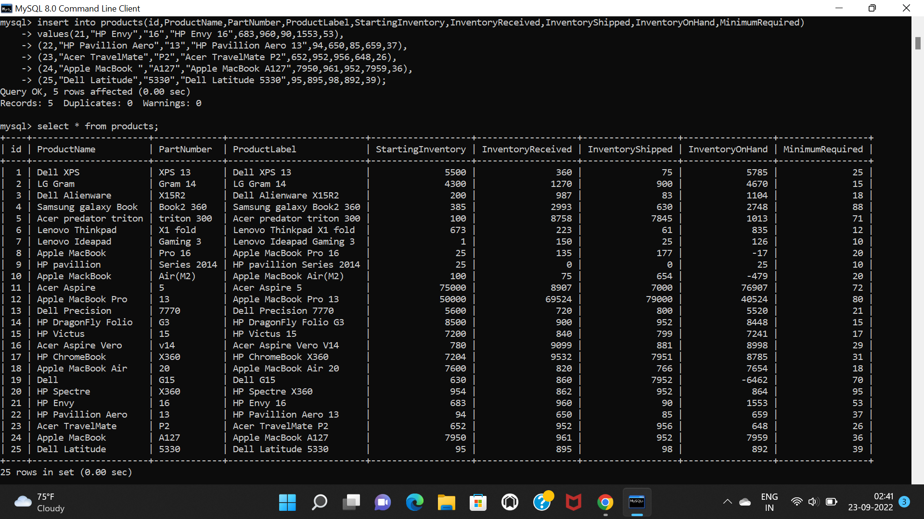

**SUPPLIERS TABLE**

**1)command to create suppliers table.**

create table suppliers(

-> id int,

-> Supplier varchar(500),

-> primary key(id)

-> );

**2)command to describe suppliers table.**

desc suppliers;

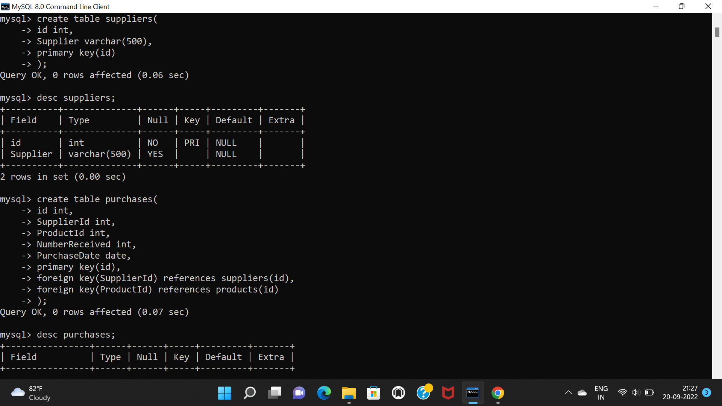

**3)command to insert records in suppliers table.**

insert into suppliers(id,supplier)

-> values(1001,"Shockwave Tech"),

-> (1002,"Acme Tech"),

-> (1003,"CDW"),

-> (1004,"Diss computers"),

-> (1005,"Hi Tech Laptops"),

-> (1006,"Mindworx InfoTech"),

-> (1007,"Falcon systems");

**4)select statement for displaying all records from suppliers table.**

select * from suppliers;

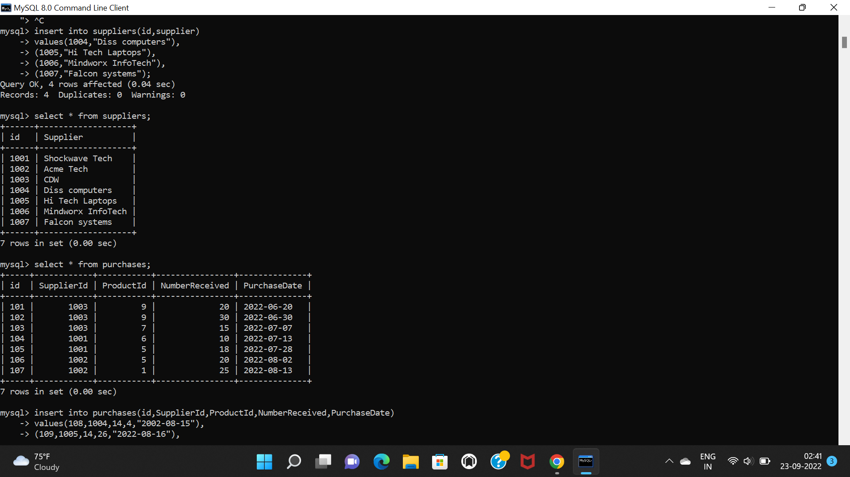

**PURCHASES TABLE**

**1)command to create purchases table.**

create table purchases(

-> id int,

-> SupplierId int,

-> ProductId int,

-> NumberReceived int,

-> PurchaseDate date,

-> primary key(id),

-> foreign key(SupplierId) references suppliers(id),

-> foreign key(ProductId) references products(id)

-> );



**2)command to describe purchases table**.

Desc purchases;

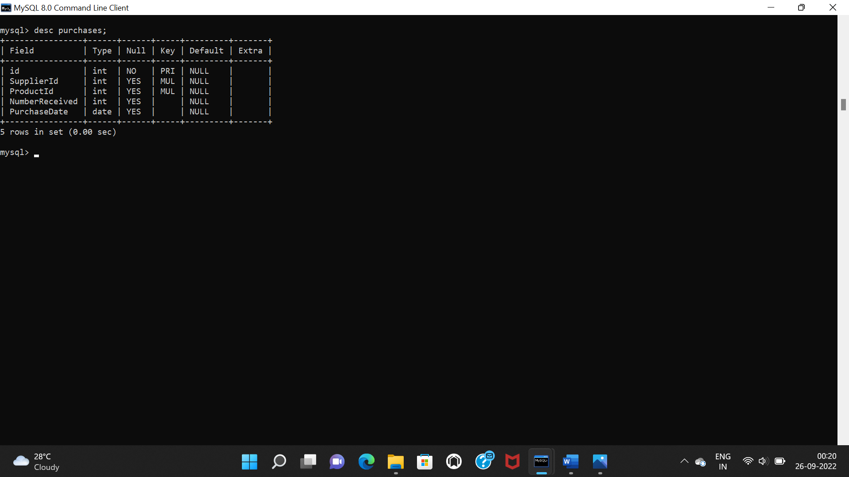

**3)command for insert records in purchases table.**

insert into purchases(id,supplierId,ProductId,NumberReceived,PurchaseDate)

-> values(101,1003,9,20,"2022-06-20"),

-> (102,1003,9,30,"2022-06-30"),

-> (103,1003,7,15,"2022-07-07"),

-> (104,1001,6,10,"2022-07-13"),

-> (105,1001,5,18,"2022-07-28"),

-> (106,1002,5,20,"2022-08-02"),

-> (107,1002,1,25,"2022-8-13"),

-> (108,1004,14,4,"2002-08-15"),

-> (109,1005,14,26,"2022-08-16"),

-> (110,1003,16,14,"2022-06-13"),

-> (111,1004,10,2,"2022-08-11"),

-> (112,1006,19,13,"2022-07-02"),

-> (113,1006,20,15,"2022-08-03"),

-> (114,1007,20,10,"2022-09-01"),

-> (115,1005,21,16,"2022-06-04"),

-> (116,1007,21,22,"2022-07-17"),

-> (117,1002,10,20,"2022-06-23"),

-> (118,1004,25,21,"2022-07-25"),

-> (119,1003,25,30,"2022-08-28"),

-> (120,1006,16,33,"2022-06-08"),

-> (121,1005,7,22,"2022-05-03"),

-> (122,1005,7,10,"2022-05-16"),

-> (123,1006,6,11,"2022-08-29"),

-> (124,1003,5,44,"2022-09-08"),

-> (125,1005,7,27,"2022-05-23");

**4)select statement for displaying all records from purchases table.**

select * from purchases;

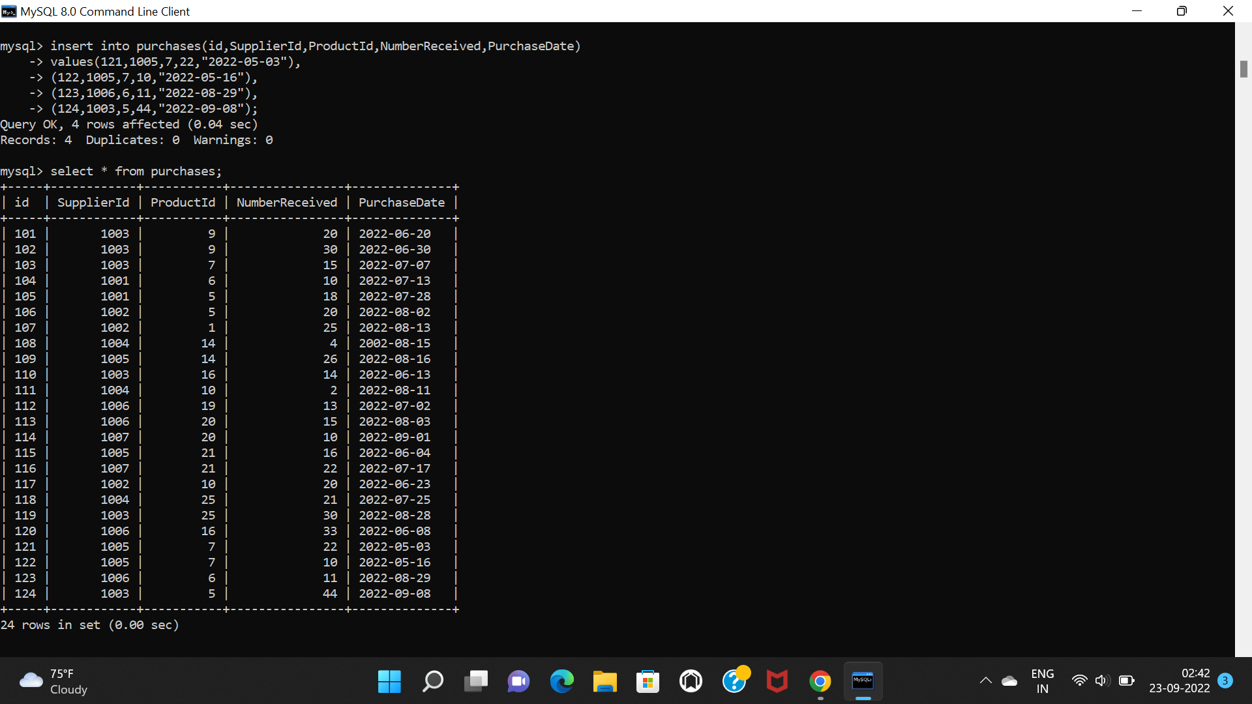

**ORDERS TABLE**

**1)command to create orders table.**

create table orders(

-> id int,

-> Title varchar(500),

-> First varchar(500),

-> Middle varchar(500),

-> Last varchar(500),

-> ProductId int,

-> NumberShipped int,

-> OrderDate date,

-> primary key(id),

-> foreign key(ProductId) references products(id)

-> );

**2)command to describe orders table.**

desc orders;

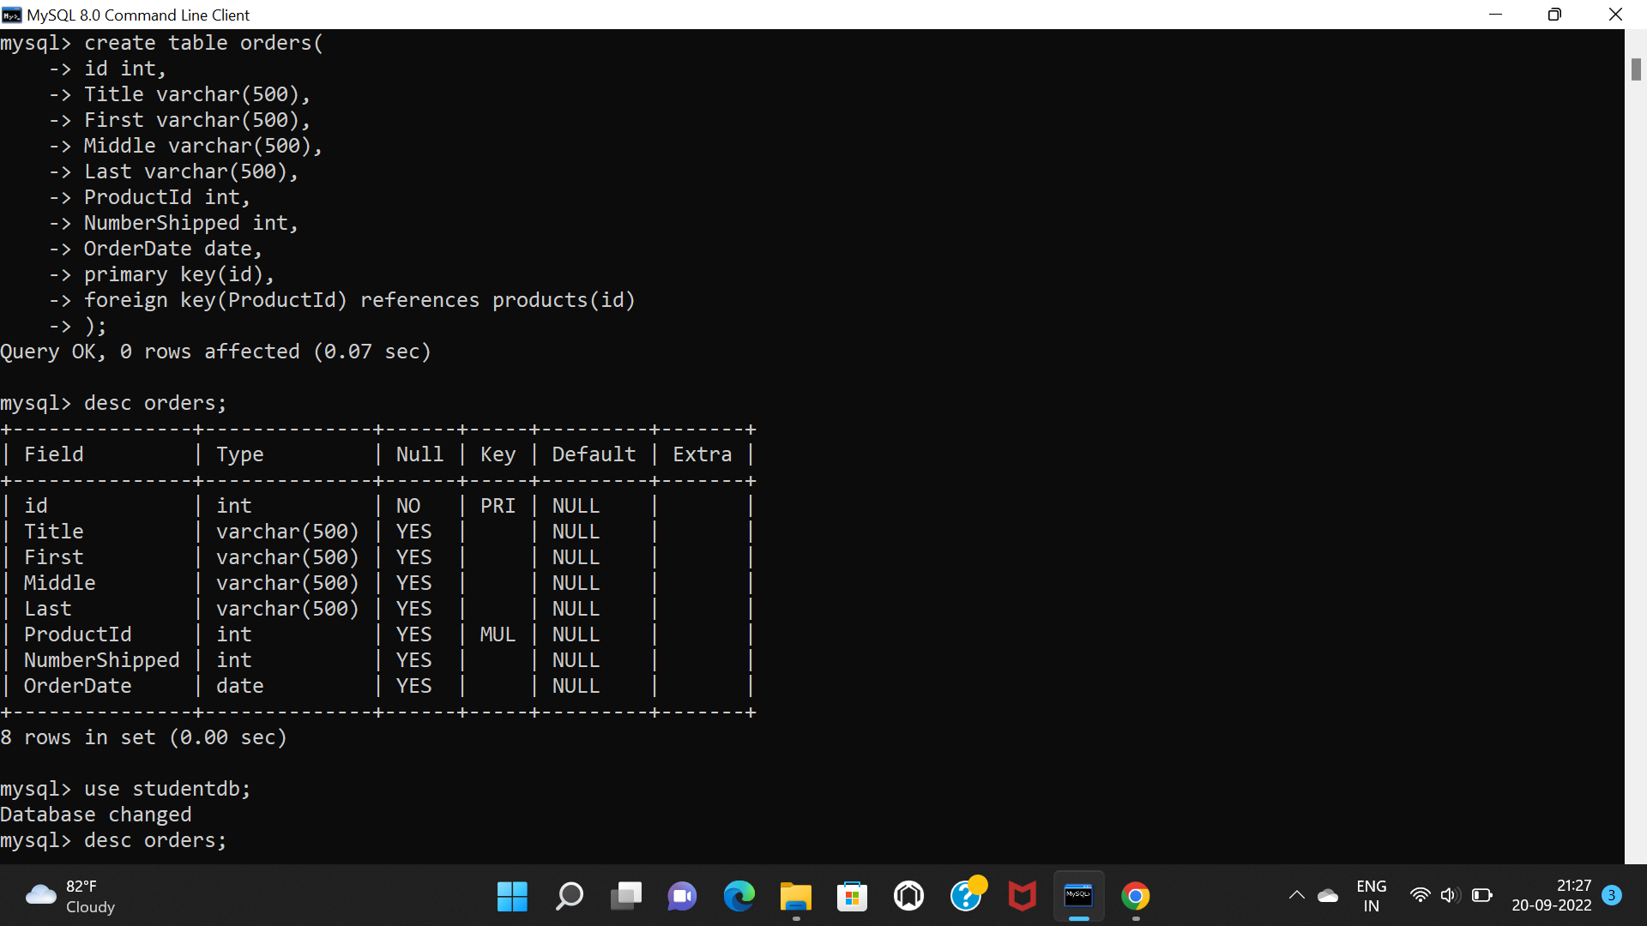

**3)command for inserting records in orders table.**

insert into orders(id,Title,First,Middle,Last,ProductId,NumberShipped,OrderDate)

-> values(10001,"Dell XPS 13","Ayush","Suresh","Shinde",1,2,"2022-08-15"),

-> (10002,"Dell XPS 13","Aarti","Ramesh","Jadhav",1,1,"2022-08-17"),

-> (10003,"Lenovo Ideapad Gaming 3","divya","Rajesh","agrawal",7,1,"2022-07-10"),

-> (10004,"Acer Predator Triton 300","Ritesh","Ramdev","Patil",5,2,"2022-07-24"),

-> (10005,"Lenovo Ideapad Gaming 3","Vanita","Ashok","Nipane",7,1,"2022-08-18"),

-> (10006,"Acer Predator Triton 300","Shashank","Dinesh","Joshi",5,2,"2022-07-20"),

-> (10007,"HP Pavillion Series 2014","Prachi","Rao","Desai",9,1,"2022-08-01"),

-> (10008,"Apple MacBook Air(M2)","aditi","santosh","sawant",10,3,"2022-08-09"),

-> (10009,"HP DragonFly Folio","sheetal","vilas","more",14,1,"2022-07-09"),

-> (10010,"HP DragonFly Folio","john","william","almedia",14,2,"2022-08-26"),

-> (10011,"Dell Latitude 5330","leander","bosco", "almedia",25,1,"2022-06-22"),

-> (10012,"HP Spectre X360","hitesh","sameer","patel",20,1,"2022-08-23"),

-> (10013,"HP Spectre X360","mukesh","jatin","gusai",20,1,"2022-05-06"),

-> (10014,"HP Envy 16","yash","rakesh","thakkar",21,1,"2022-06-22"),

-> (10015,"HP Envy 16","jyoti","vilas","salunkhe",21,1,"2022-06-24"),

-> (10016,"Dell G15","shravani","krishna","kadam",19,1,"2022-07-25"),

-> (10017,"Dell G15","harisha","lokesh","rajput",19,1,"2022-07-05"),

-> (10018,"Dell G15","seema","vishal","nipane",19,1,"2022-08-05"),

-> (10019,"Acer Aspire Vero","samiksha","santosh","shinde",16,3,"2022-05-25"),

-> (10020,"Acer Aspire Vero","rutuja","kishor","sawant",16,2,"2022-08-23"),

-> (10021,"Lenovo Thinkpad X1","natasha","ravi","birla",6,3,"2022-08-09"),

-> (10022,"Lenovo Thinkpad X1","tina","ratan","dabi",6,1,"2022-08-18"),

-> (10023,"Dell XPS 13","flowy","mario","corriea",1,1,"2022-06-08"),

-> (10024,"Dell XPS 13","ajinkya","daulat","gajare",1,2,"2022-07-29"),

-> (10025,"Acer Predator Triton","pranav","dheraj","joshi",5,1,"2022-06-16");

**4)select statement to display all records from orders table.**

select * from orders;

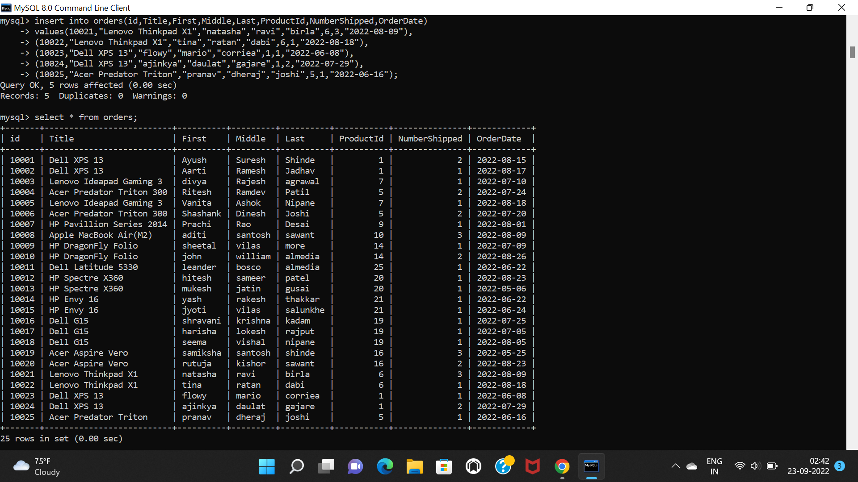

**FINDING INSIGHTS FROM ABOVE TABLEs**

**1)USING JOINS:**

**1)fetch sum of inventory on hand of products which are more than 5000 and productname using aggregate function.**

select ProductId,ProductName,sum(InventoryOnHand) from purchases

inner join products

on products.id=purchases.ProductId

group by ProductId,ProductName

having sum(InventoryOnHand)>5000;

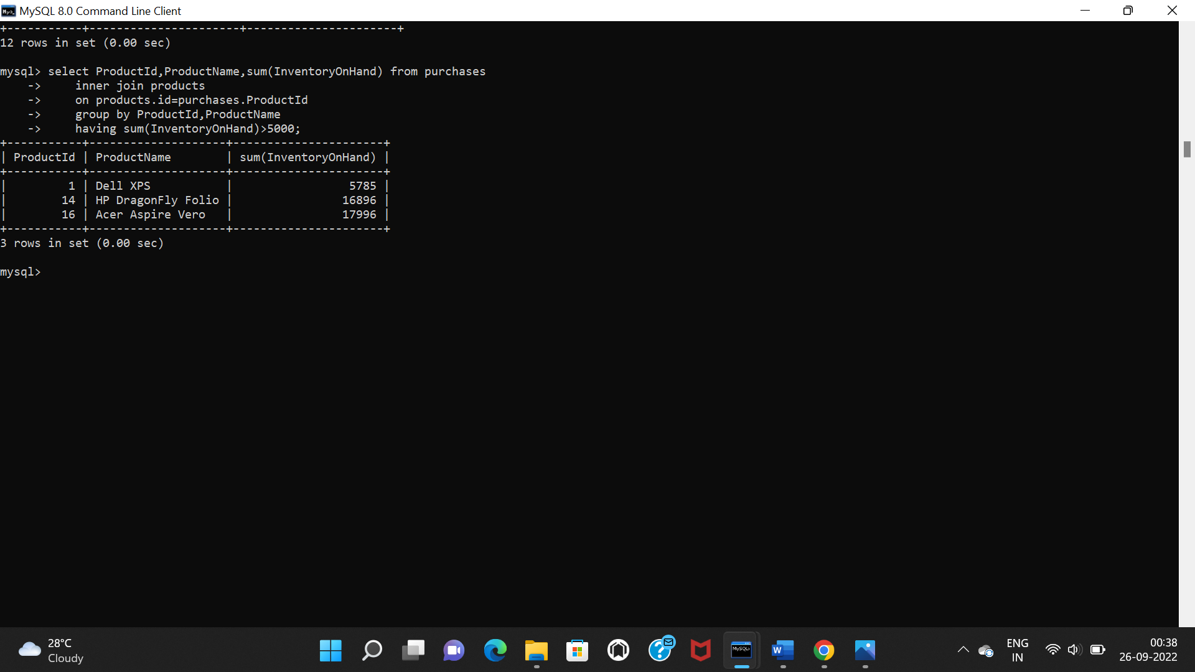

**2)fetch products details which are from “HP” brand with its purchase date.**

select ProductId,ProductName,PurchaseDate from products

inner join purchases

on products.id=purchases.ProductId

where ProductName like "HP%";

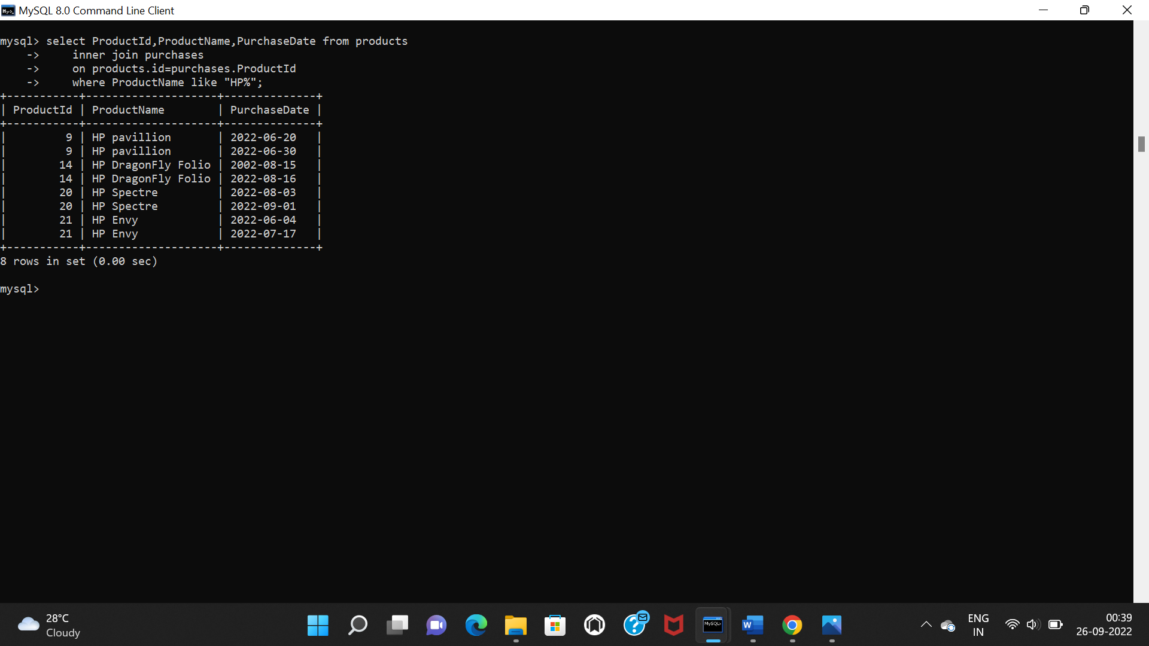

**3)fetch average of InventoryOnHand and productname of common products using aggregate function.**

select ProductId,ProductName,avg(InventoryOnHand) from purchases

inner join products

on products.id=purchases.ProductId

group by ProductId,ProductName;

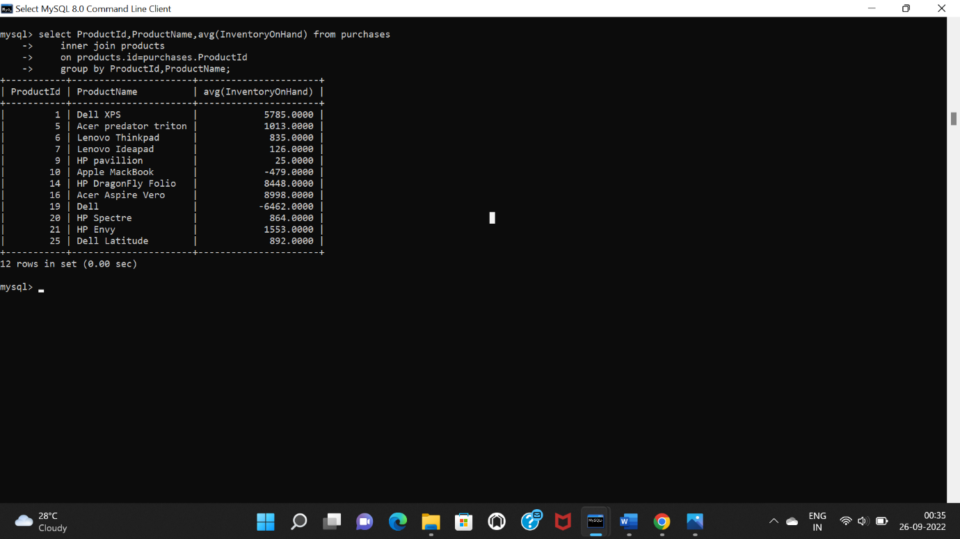

**4)left join between products and purchases.**

select ProductId,ProductName,PurchaseDate from products

left join purchases

on products.id=purchases.ProductId;

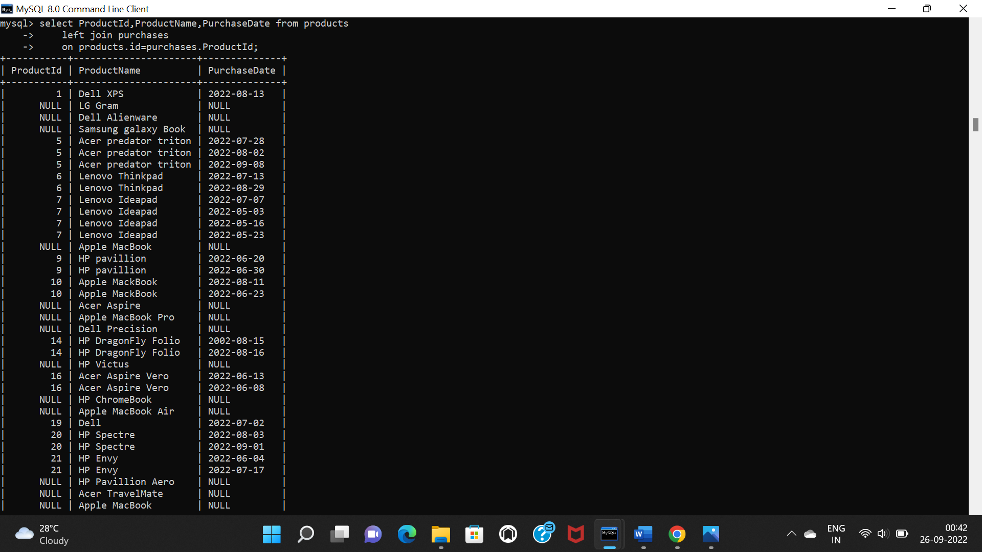

**5)right join between products and purchases.**

select ProductId,ProductName,PurchaseDate from products

right join purchases

on products.id=purchases.ProductId;

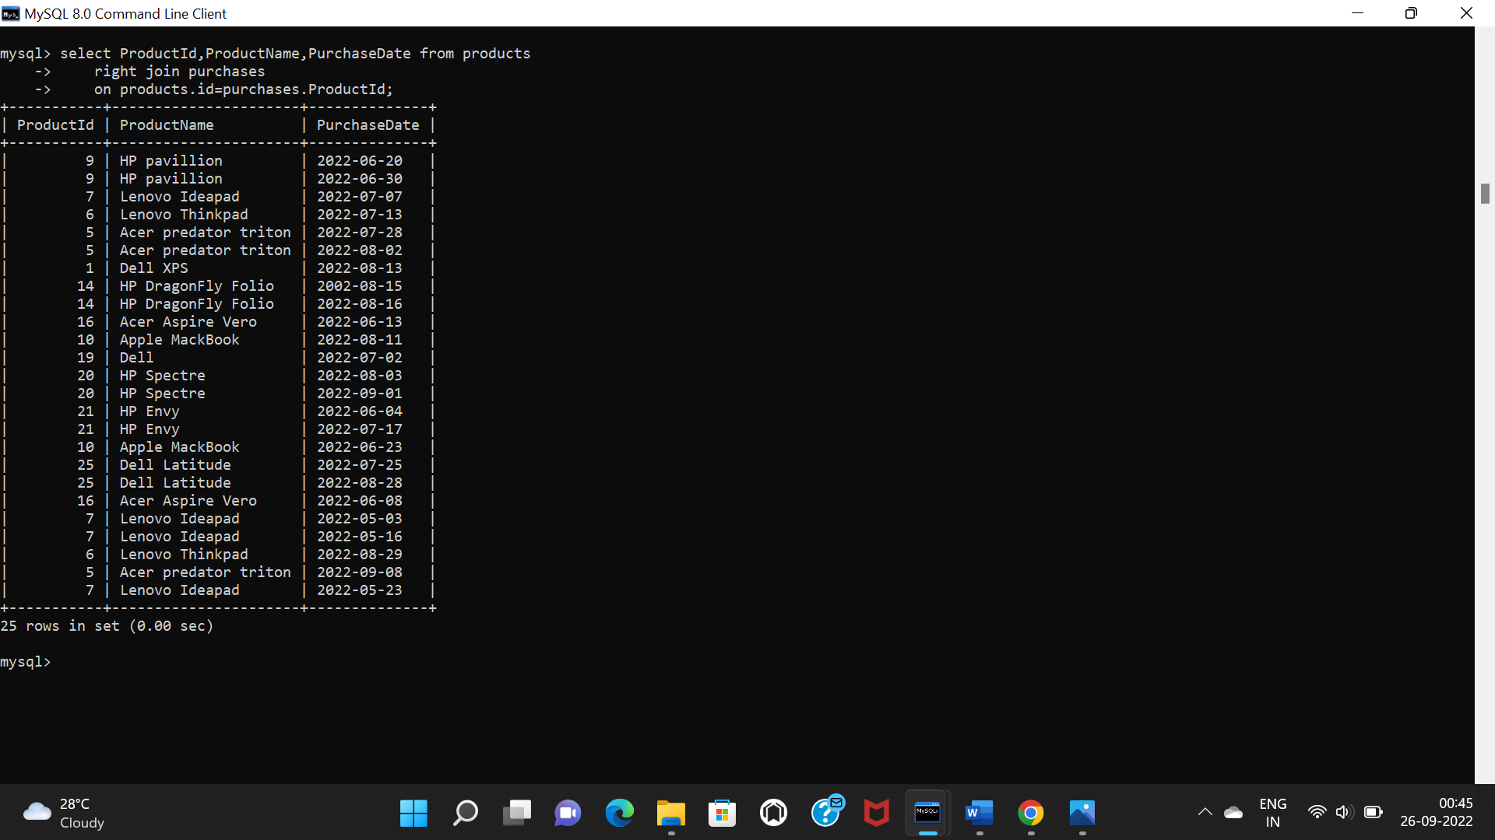

**6)fetch productname along with purchasesdate between 2022-08-1 and 2022-08-30 .**

select ProductId,ProductName,PurchaseDate from products

inner join purchases

on products.id=purchases.ProductId

where PurchaseDate between "2022-08-01" and "2022-08-30";

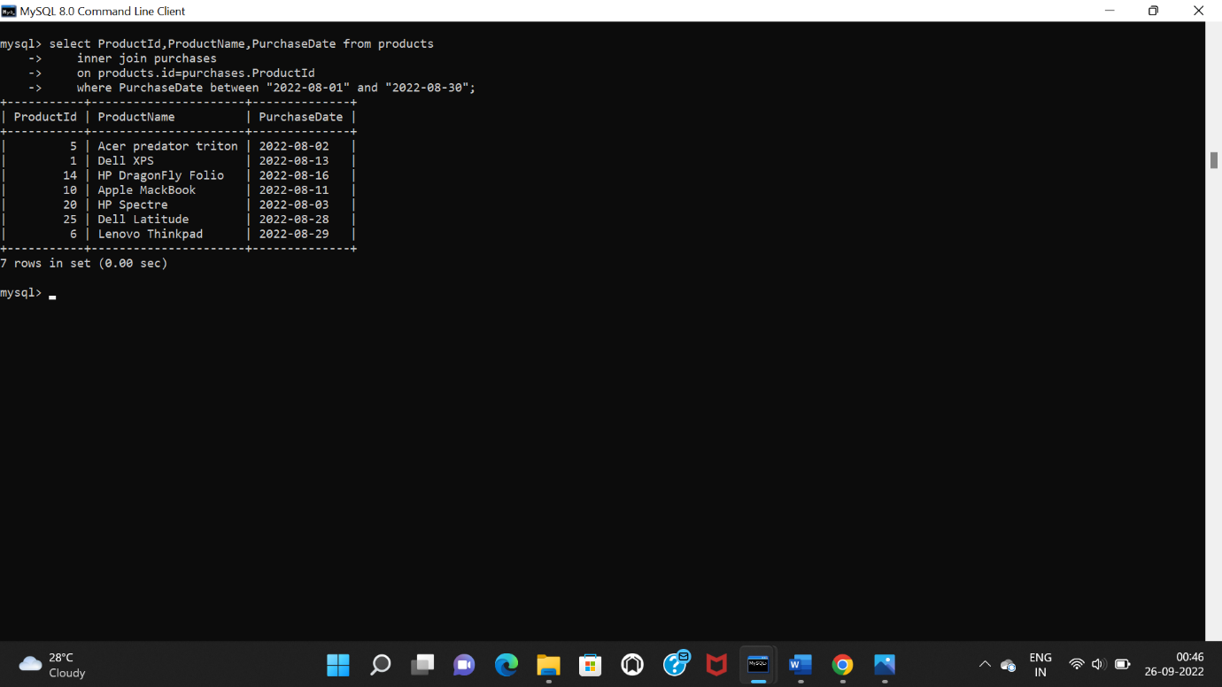

**7)fetch products details which are having “Lenovo” brand.**

select ProductId,ProductName from products

inner join purchases

on products.id=purchases.ProductId

group by ProductId

having ProductName like "Lenovo%";

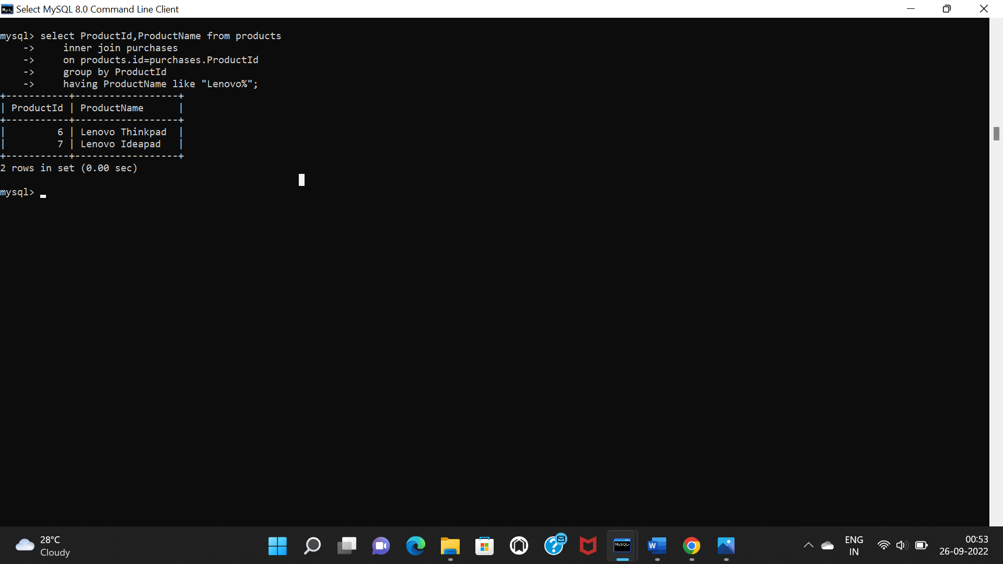

**8)fetch product details which has orderdate between 2022-07-01 and 2022-07-30.**

select ProductId,First,ProductName,InventoryReceived from orders

inner join products

on orders.ProductId=products.id

where OrderDate between "2022-07-01" and "2022-07-30";

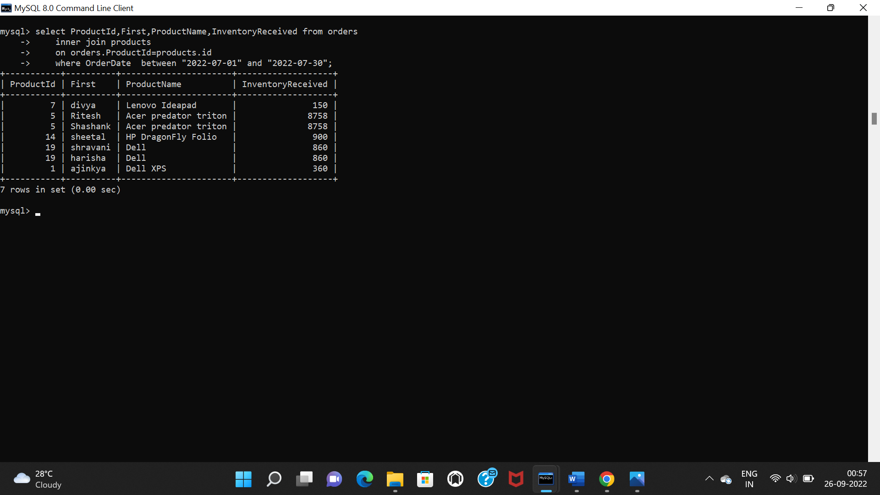

**9)fetch product details where buyer name start with “s” alphabet and having buyer full name.**

select ProductId,concat(First," ",Last),ProductName from orders

inner join products

on orders.ProductId=products.id

where first like "s%";

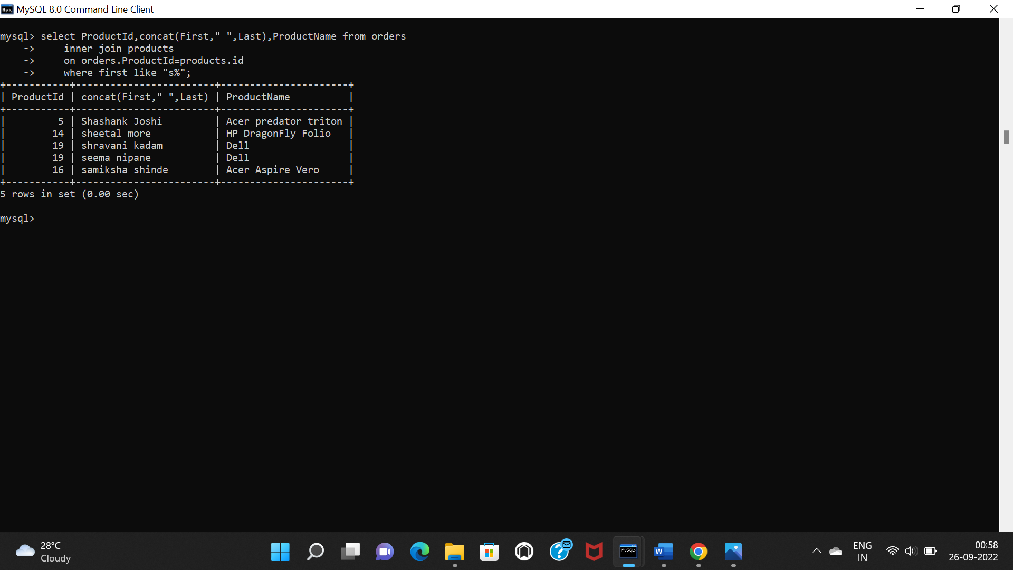

**10)fetch products details where number of products shipped/delivered is more than or equal to 2.**

select ProductId,ProductName,First from orders

inner join products

on orders.ProductId=products.id

group by ProductId,NumberShipped

having NumberShipped>=2;

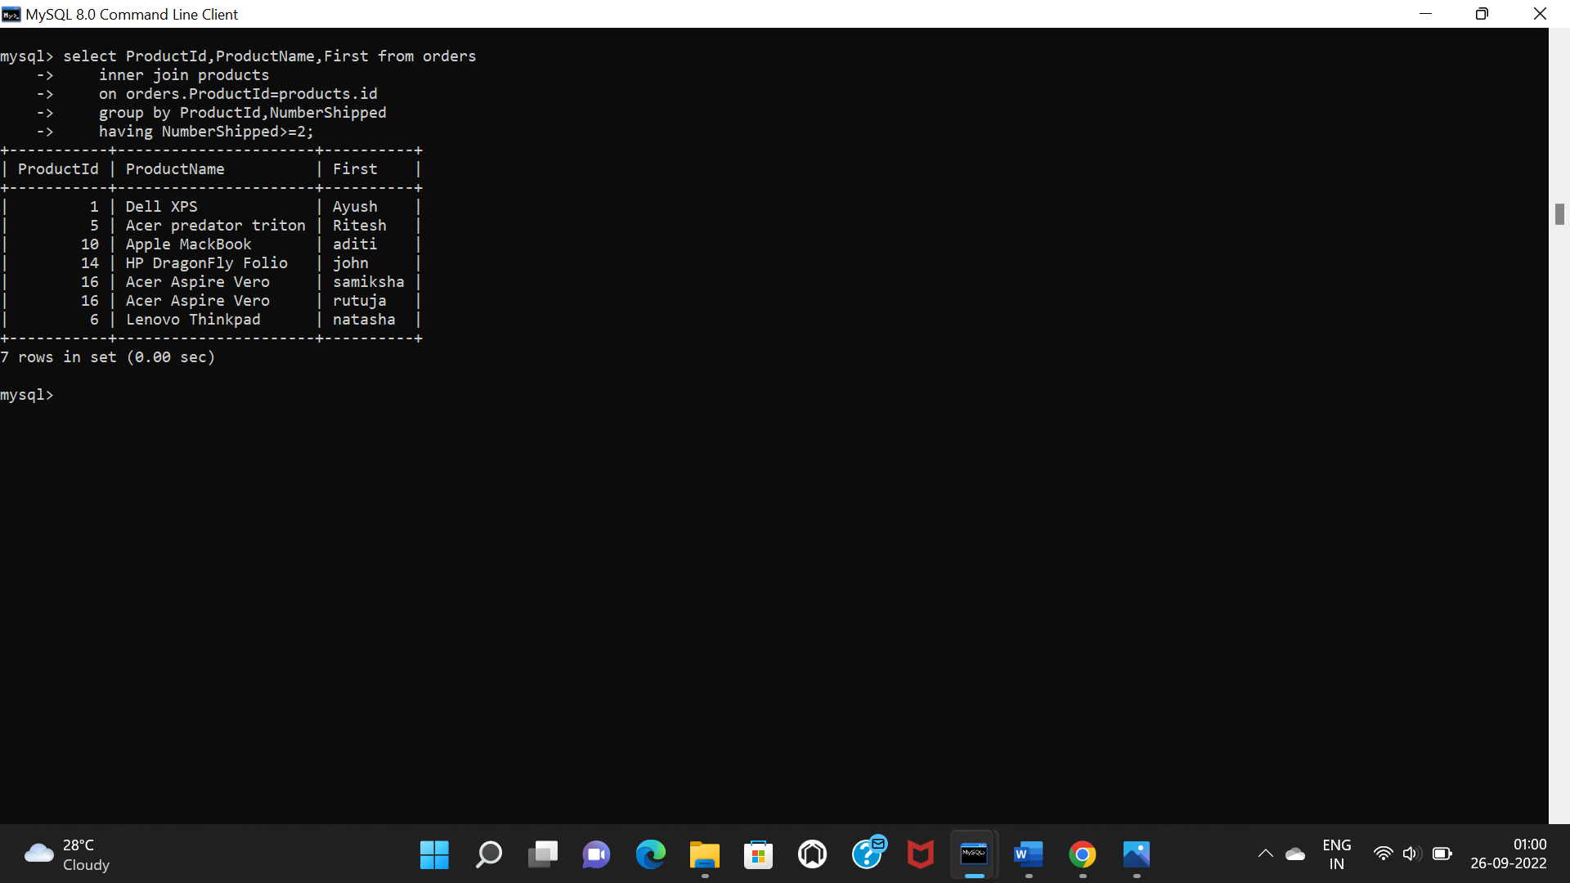

**11) right join between products and orders fetching first 10 records.**

select orders.id,ProductId,ProductName from products

left join orders

on orders.ProductId=products.id

order by ProductName asc

limit 10;

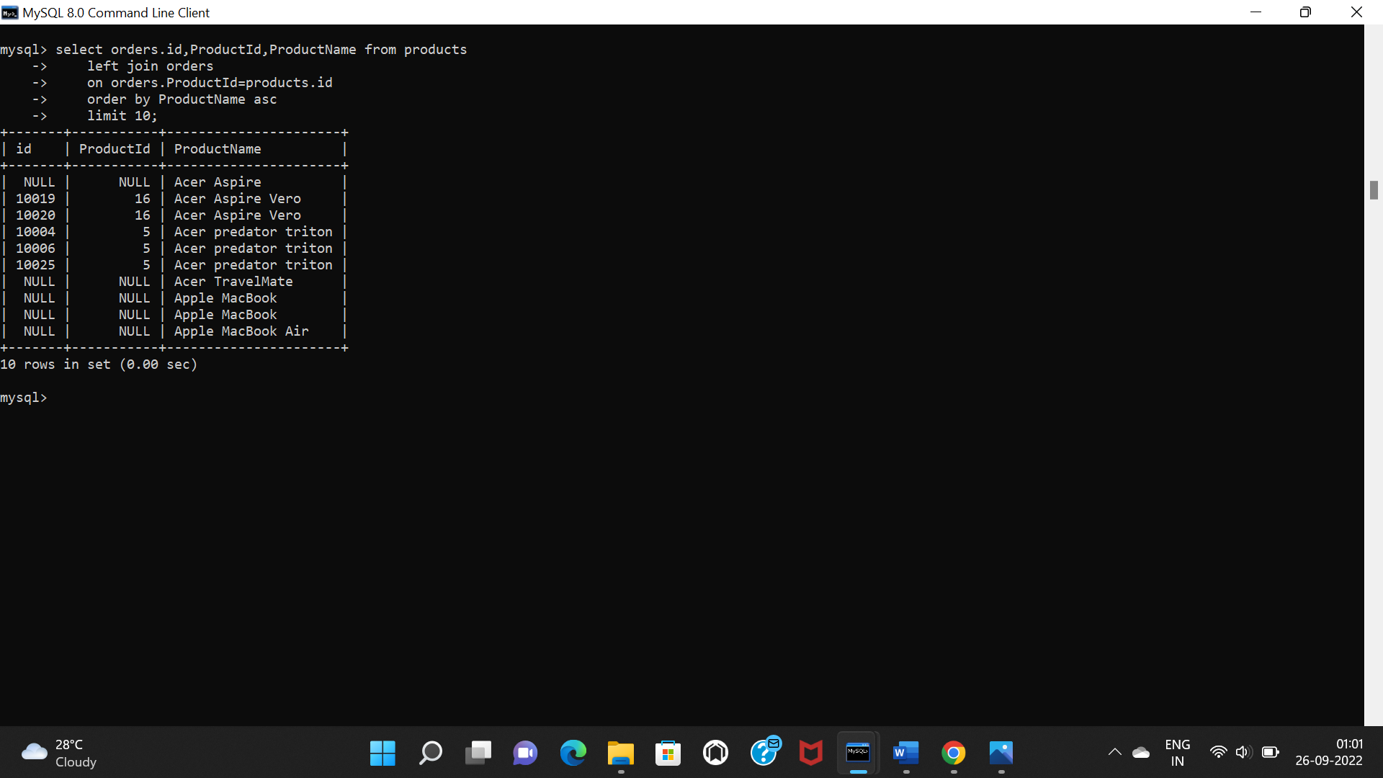

**12) right join between products and orders fetching first 5 records.**

select orders.id,ProductId,ProductName,First from products

right join orders

on orders.ProductId=products.id

order by ProductName desc

limit 5;

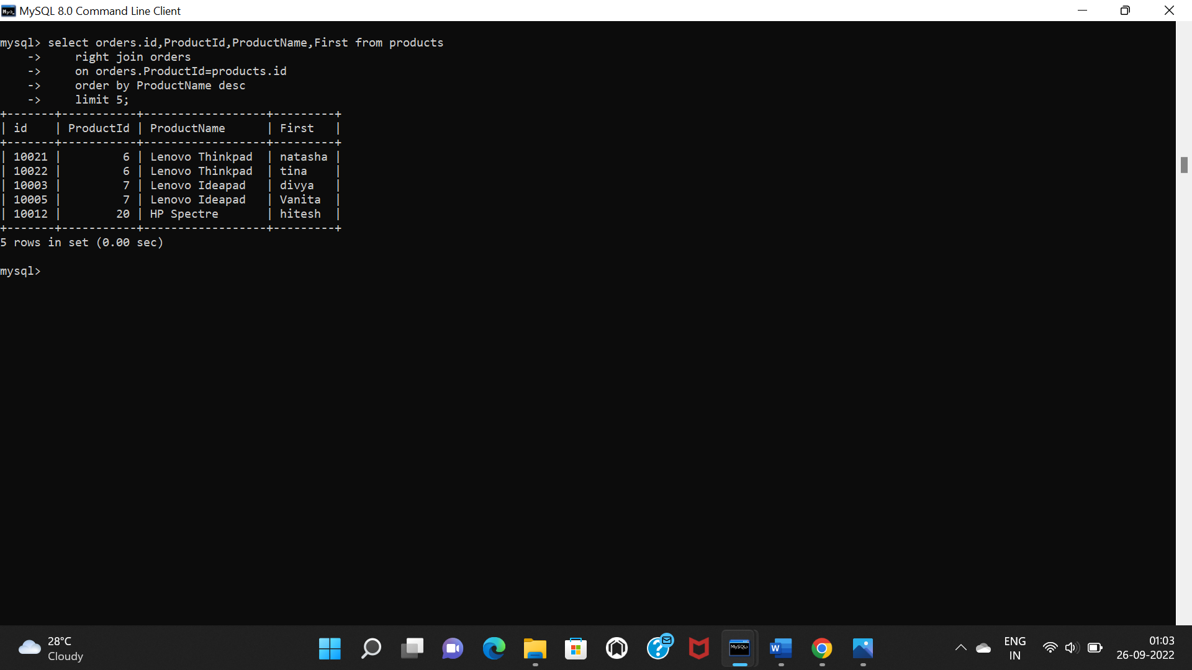

**13)fetch suppliers details where purchase date is between 2022-06-01 and 2022-06-30.**

select suppliers.id,suppliers.supplier,PurchaseDate from suppliers

inner join purchases

on suppliers.id=purchases.SupplierId

where PurchaseDate between "2022-06-01" and "2022-06-30";

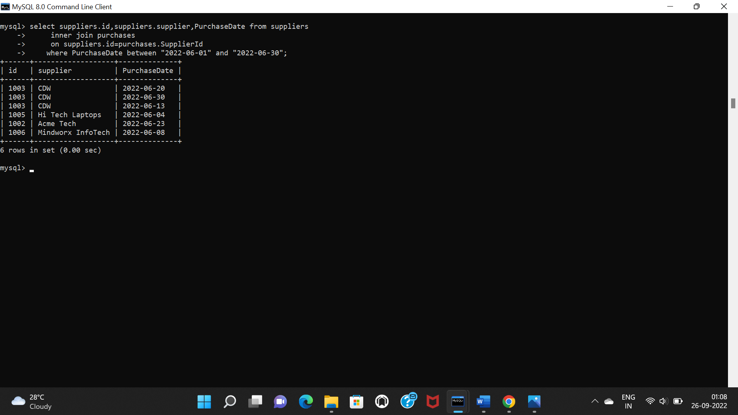

**14) fetch product details where suppliername is ”cdw”.**

select suppliers.id,ProductName,supplier from products

inner join purchases

on products.id=purchases.ProductId

inner join suppliers

on purchases.SupplierId=suppliers.id

where supplier="cdw";

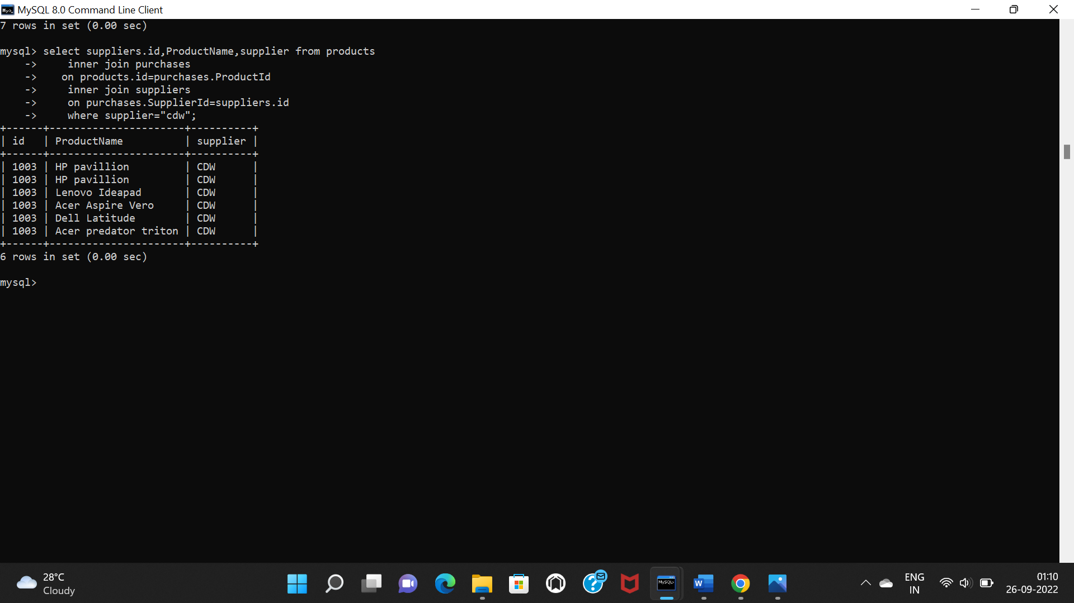

**15)fetch first,second and third highest starting inventory.**

select * from products order by StartingInventory desc limit 1;

select * from products order by StartingInventory desc limit 1,1;

select * from products order by StartingInventory desc limit 2,1;

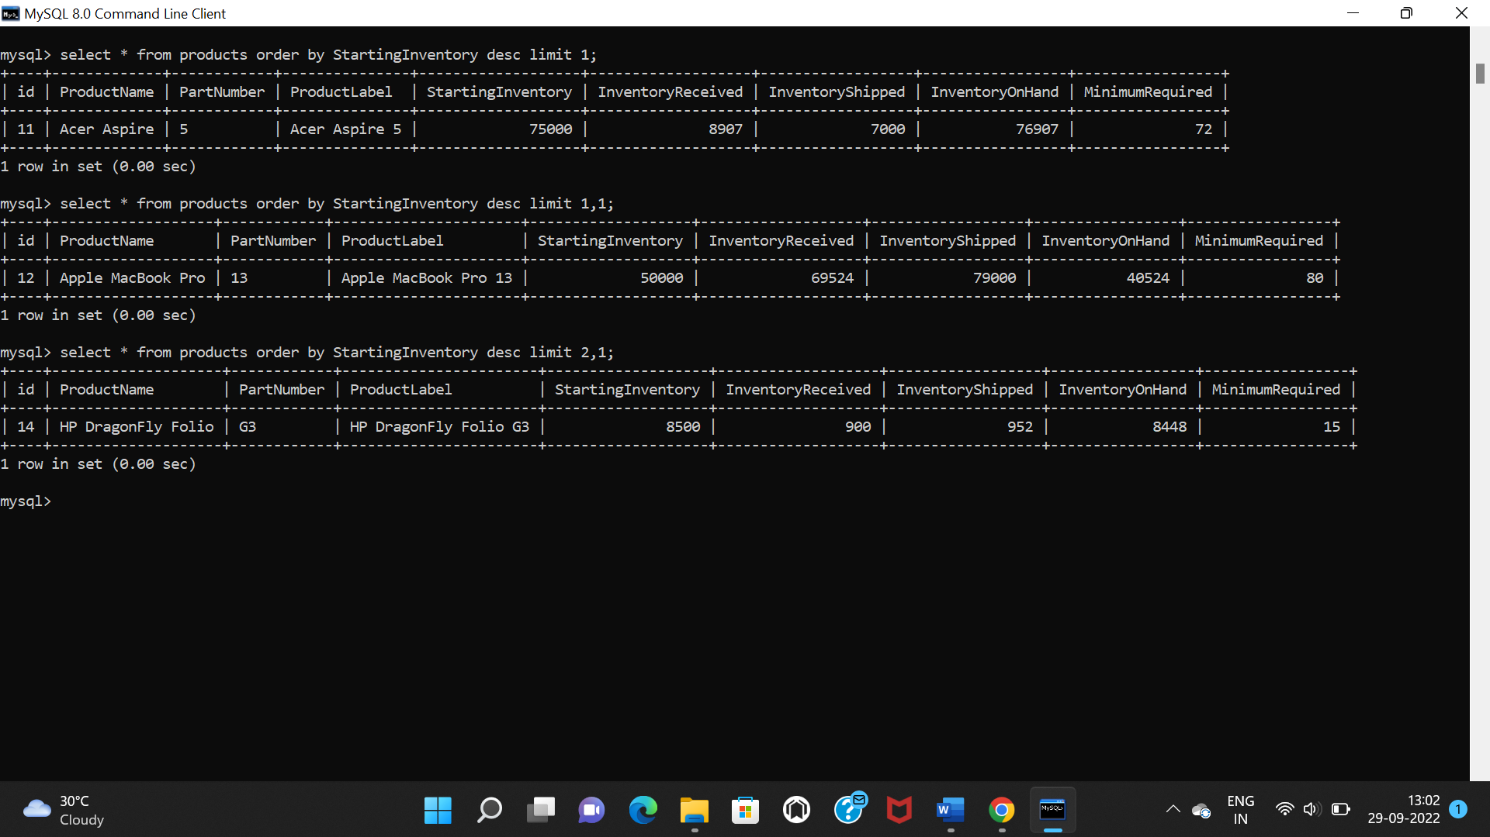

**2)USING SUBQURIES:**

**1)fetch products details where numbers of product shipped is more than or equal to 2 and orderdate is between 2022-07-01 and 2022-07-30.**

select * from products where id in(select ProductId from orders where NumberShipped>=2 and OrderDate between "2022-07-01" and "2022-07-30");

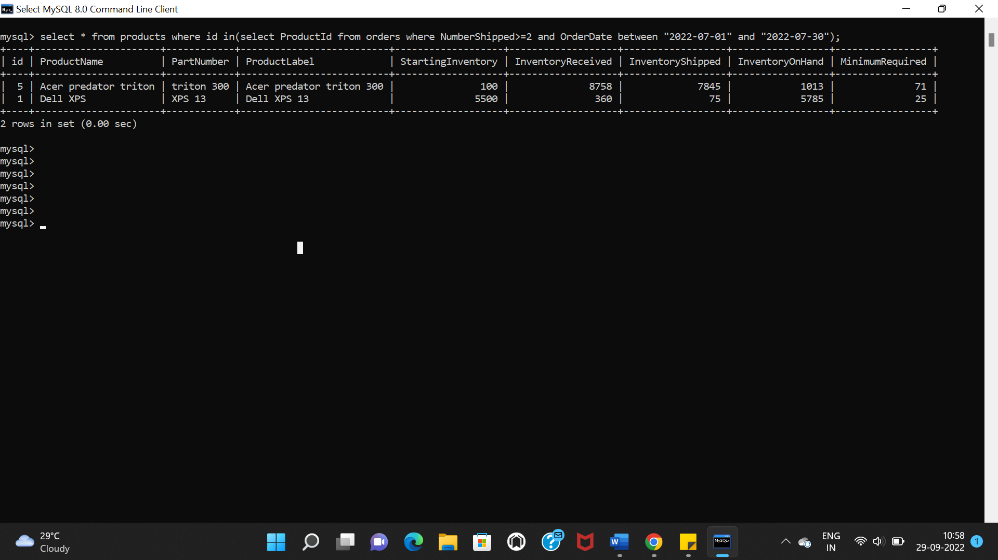

**2)fetch purchases details where starting inventory of product is more than 7000.**

select * from purchases where ProductId in(select id from products where StartingInventory>7000);

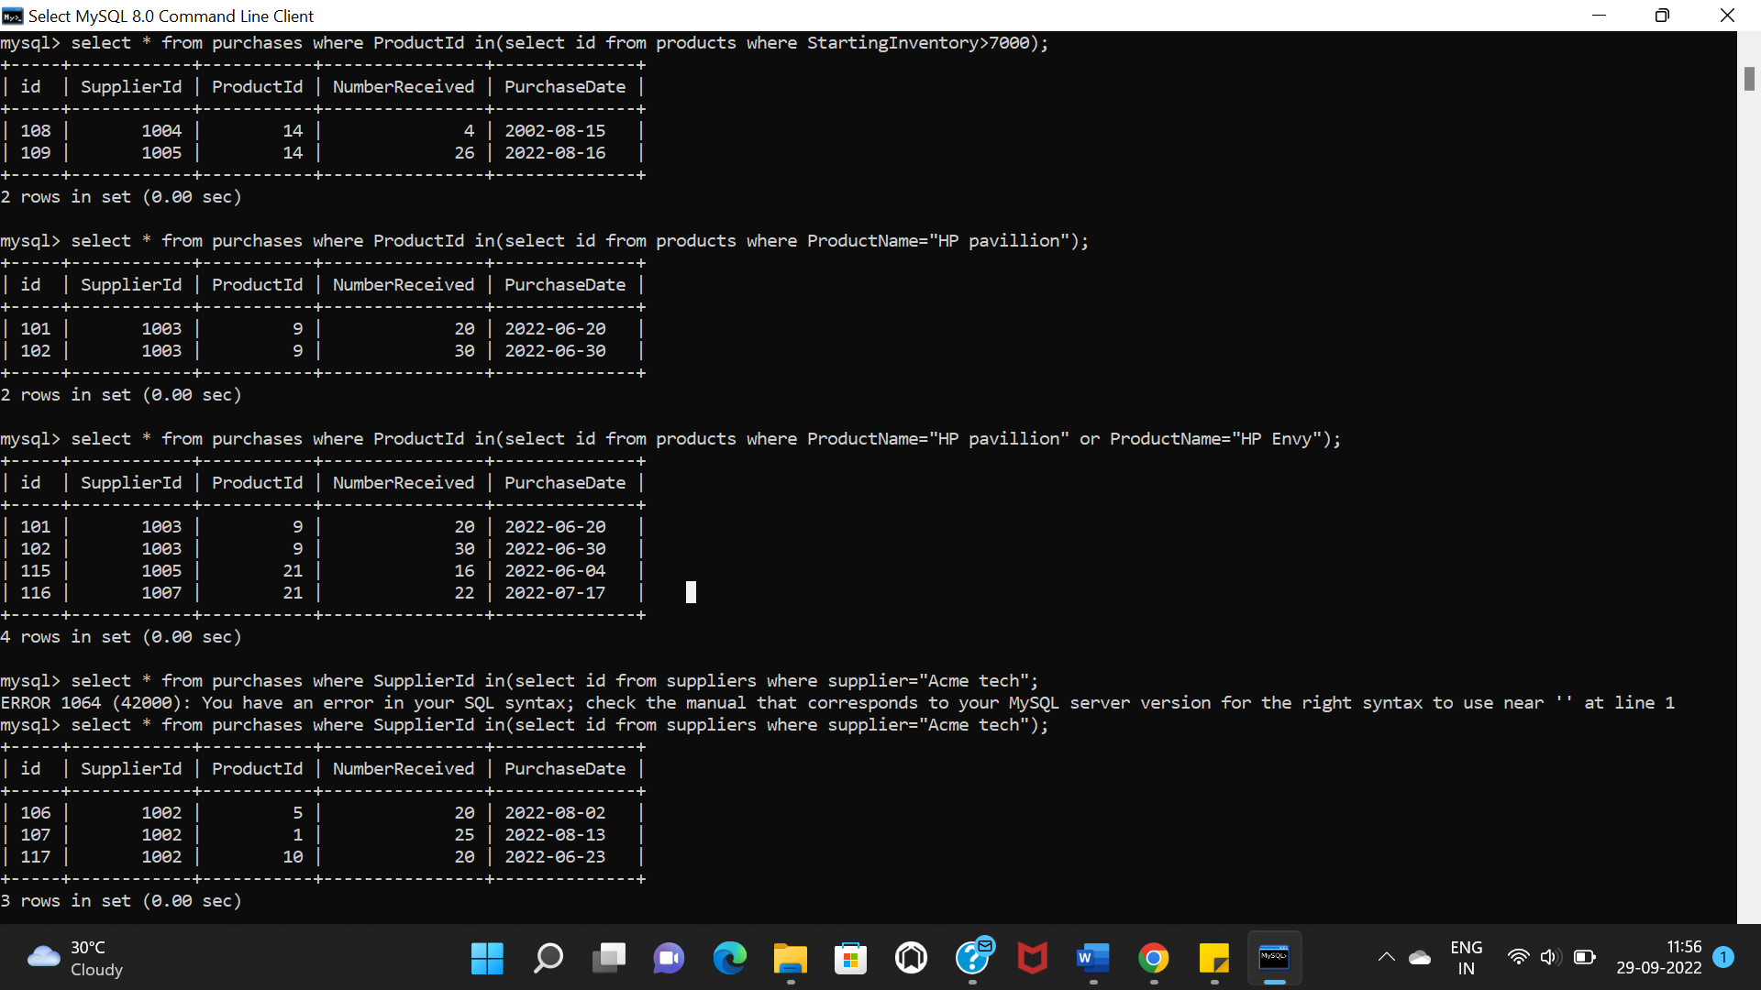

3)**fetch purchases details of products where productname is “HP pavillion” and “HP Envy”.**

select * from purchases where ProductId in(select id from products where ProductName="HP pavillion" or ProductName="HP Envy");



**4)fetch purchases details of products where “Acme tech” is supplier of products.**

select * from purchases where SupplierId in(select id from suppliers where supplier="Acme tech");

